**Year 2018**

**VCE**

**Mathematical Methods**

**Trial Examination 1**

**Solutions**

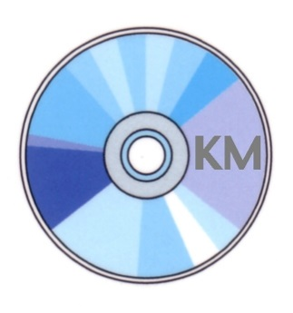

|  |  |
| --- | --- |
| **KILBAHA MULTIMEDIA PUBLISHING**  **PO BOX 2227**  **KEW VIC 3101**  **AUSTRALIA** | **TEL: (03) 9018 5376**  **FAX: (03) 9817 4334**  **kilbaha@gmail.com**  **http://kilbaha.com.au** |

IMPORTANT COPYRIGHT NOTICE

1. This material is copyright. Subject to statutory exception and to the provisions of the relevant collective licensing agreements, no reproduction of any part may take place without the written permission of Kilbaha Multimedia Publishing.
2. The contents of this work are copyrighted. Unauthorised copying of any part of this work is illegal and detrimental to the interests of the author.
3. For authorised copying within Australia please check that your institution has a licence from Copyright Agency Limited. This permits the copying of small parts of the material, in limited quantities, within the conditions set out in the licence.

Reproduction and communication for educational purposes The Australian Copyright Act 1968 (the Act) allows a maximum of one chapter or 10% of the pages of this work, to be reproduced and/or communicated by any educational institution for its educational purposes provided that educational institution (or the body that administers it) has given a remuneration notice to Copyright Agency Limited (CAL) under the Act.

For details of the CAL licence for educational institutions contact

CAL, Level 15, 233 Castlereagh Street, Sydney, NSW, 2000

Tel: (02) 9394 7600

Fax: (02) 9394 7601

Email: [info@copyright.com.au](mailto:info@copyright.com.au)

Web: <http://www.copyright.com.au>

* While every care has been taken, no guarantee is given that these answers are free from error. Please contact us if you believe you have found an error.

**Question 1**

**a.**  using the quotient rule

 M1

 A1

**b.** Let 

 chain rule



M1



 A1

**Question 2**



 A1





 since  M1

 A1

**Question 3**

**a.**  chain rule

 A1

 M1



 A1

**b.i.**  however  A1



**ii.** Using the product rule and **a.**



 for maximum M1



 since 

 A1

**Question 4**

**a.** 

 M1



 as the only answer A1

**b.** Let 

 M1

 A1

**Question 5**

**a.i** number of red, 0, 1, 2, 3, in a total of 10, so 

 A1

**ii. **

 A1

**b.** 

 A1



 A1

**Question 6**

**a.** completing the square



range  A1

 domain , range *R*

|  |  |  |
| --- | --- | --- |
|  |  |  |
| domain |  |  |
| range |  |  |

Since range domain , so  does not exist. A1

**b.** solving 

 M1

now , so if we now restrict the domain of *g*, as

domain  domain  now the range of *g*

so range domain , so now exist. A1



 A1

**Question 7**

**a.** Since it is discrete probability distribution 



 M1



 since 

but is not valid as  and each probability must be positive.

 are the only answers in  A1

**b.** 







 A1

**Question 8**

**a.** The sine wave part has a length of , and is one quarter of a cycle,

therefore one cycle  A1

**b.** Since the function is continuous at ,  A1

Since the total area under the curve is one.

 M1

 substitute , solve for *k* M1



 A1

**Question 9**

**a.** Let  using the product rule



 A1

**b.**  using the product rule



for turning points  M1



the minimum turning point is  A1

**c.** 

from **a.** 

 M1

 A1



 A1

**END OF SUGGESTED SOLUTIONS**